Robert Minson

March 22, 2023

SYM-408

Prof. Dilts

Reporting Services

Code in SSDT that to pull name, credit rating, preferred vendor status, and active flag from the purchasing vendor table.

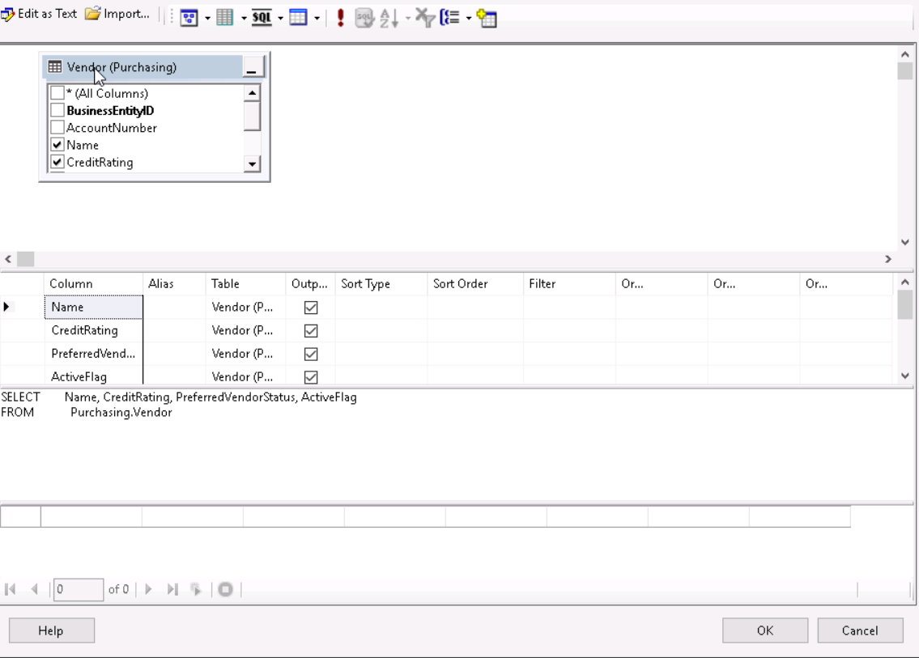

Report generated from the previous code and formatted to be business appropriate.

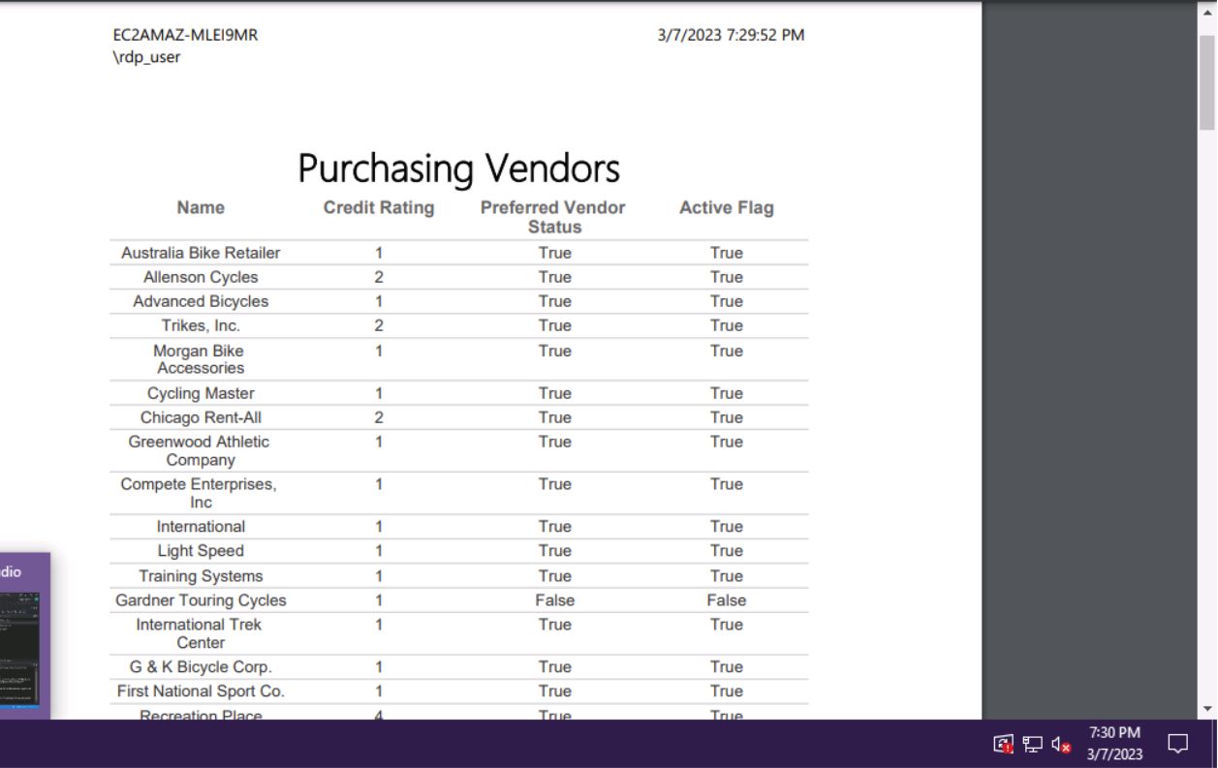

Code in SSDT gathering the name, credit rating, preferred vendor status, and active flag from vendor table. The minimum order quantity, maximum order quantity, and on order quantity, when it equals null, from the product vendor table.

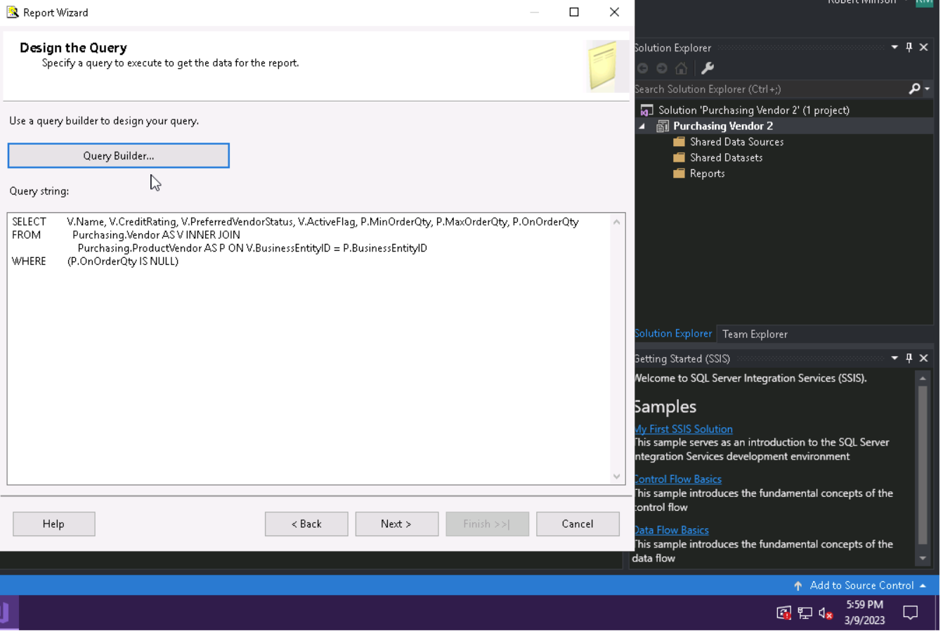

Appropriately formatted report generated from the previous code.

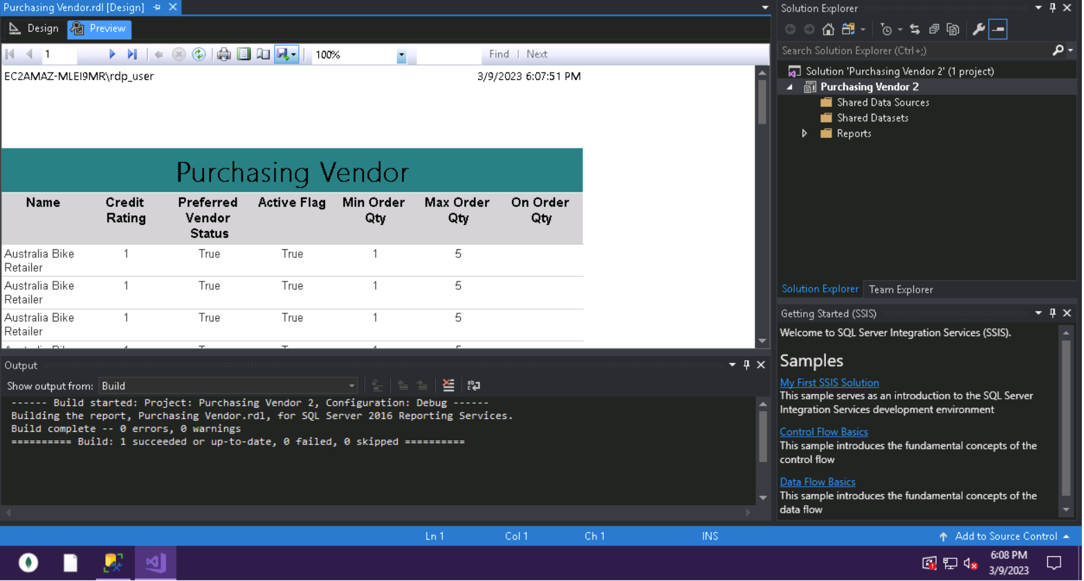

References

Erkec, E. (2019, February 21). *SQL server reporting services architecture and component topology.* SQL Shack. Retrieved from https://www.sqlshack.com/sql-server-reporting- services-architecture-and-component-topology/